Be Part of
Waterloo SpringFest
April 30, 2016
10 a.m. – 3 p.m.
Seeking Sponsors, Parade Entries,
Food, Arts & Craft Vendors
Classic cars, trucks and tractors

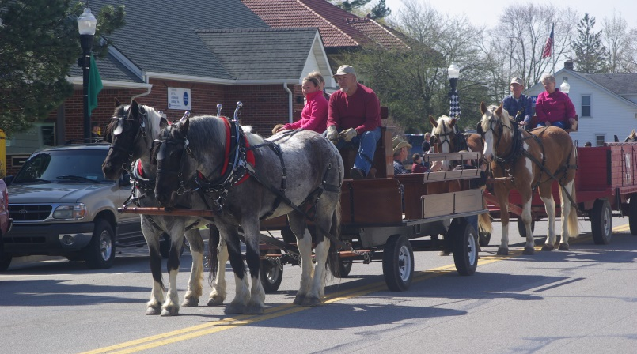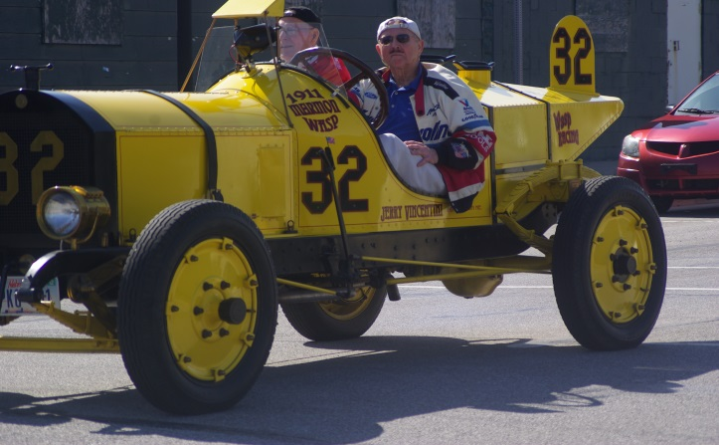

Sign Up Today at Waterloo Town Hall
280 N. Wayne Street, 837-7428
or get your sign-up form at www.mywaterlooindiana.com
and email it to: waterlootwnmgr@mchsi.com

