Artists Wanted
Waterloo Holiday Train Block Party

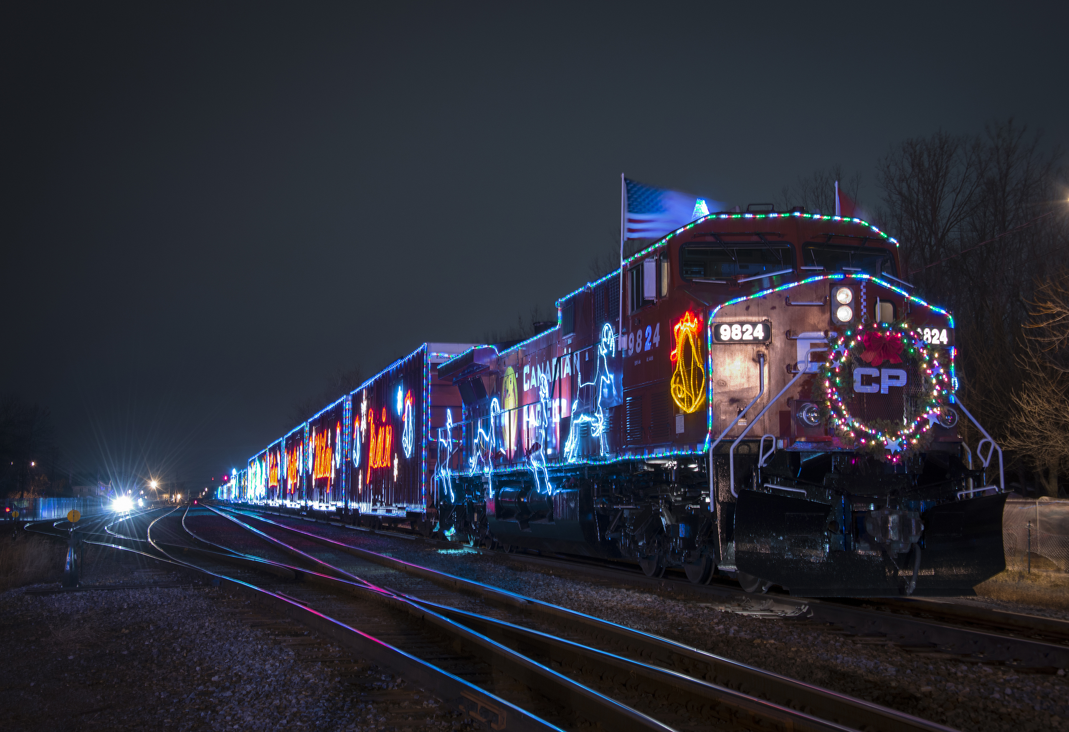
Nov. 30, 8 p.m. – 1 a.m. Waterloo Depot
485 W Van Vleek Street, Waterloo IN 46793

Name of contact person__________________________ Business________________________________
Address: _____________________________________________________________________________
Contact phone number_______________________ Email Address_______________________________
SPONSORS: Sponsors are promoted in advance and at the event on banners and signage.
Sponsorship Levels (check one): ___ $150 – Logo & Name on all publicity
___$75 – Name/logo on event banner

VENDORS: We’ll provide a 10x10’ space under a large tent and marketing/promotions. You will not need a permit. Please bring your own tables, display equipment. Setup is after 1 p.m. in event tent or pavilion.

Booth spaces:
_____$20 Arts, Crafts and Food sales ______$10 Non-Profit Organization _____$5 electrical service fee

What type of products do you sell:_________________________________________________________
_____________________________________________________________________________________

_____________________________________________________________________________________

Return this registration along with fees to:
Town Manager, Waterloo Main Street, P.O. Box 96 Waterloo, IN 46793

Sponsored by Waterloo Main Street & Friends of the Depot.
Waterloo Main Street
Incorporated Town of Waterloo, Indiana
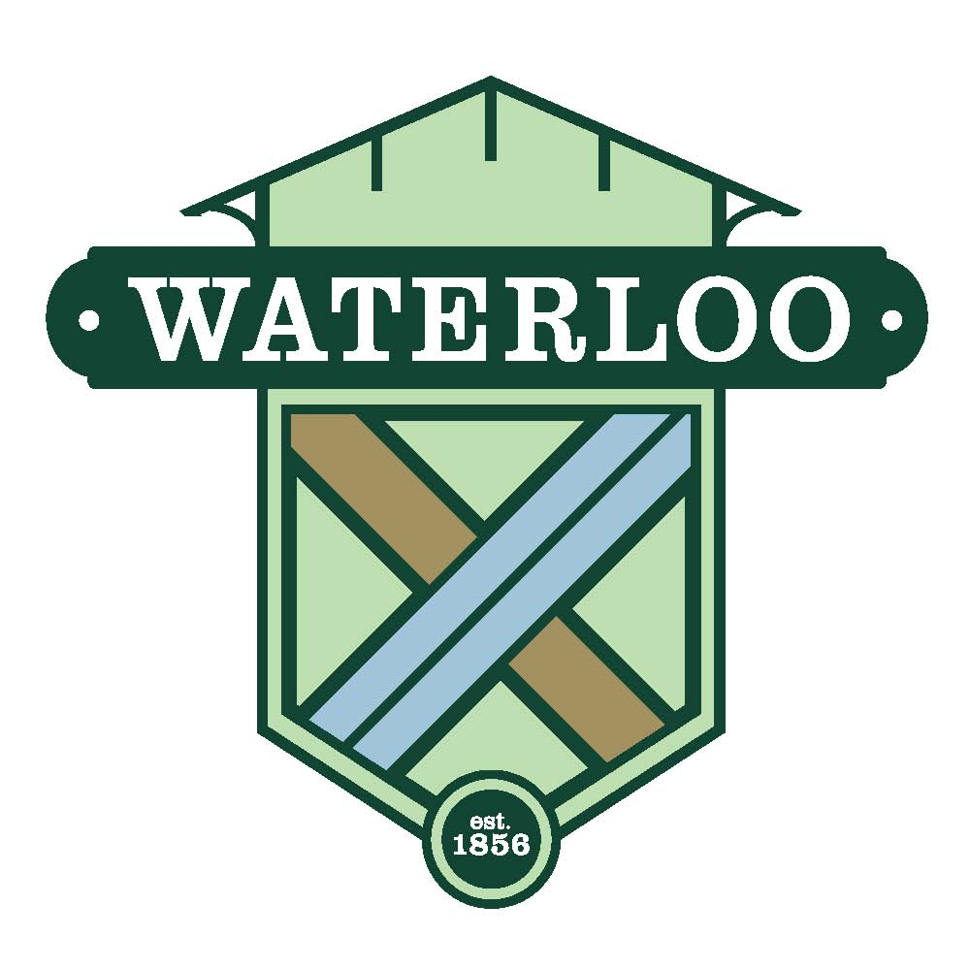
Town Manager
P.O. Box 96 280 S. Wayne Street
Waterloo, Indiana 46793
Tel: 260-837-7428 Fax: 260-837-3605
e-mail: townmanager@waterlooin.gov
Website: www.waterlooin.gov

August 1, 2018

The Town of Waterloo invites you to join us in a new event. Take part in our celebration as the Canadian Pacific Holiday Train makes the 20th annual trip covered in beautiful lights.

Last year, we opened the depot so the public had a comfortable place to wait for the CP Holiday Train as it made its way to Chicago. Hundreds of people came from miles around to see the train. Everyone had a great time and we are encouraged to do it again.

So, in November we’re going to make this event even better. Instead of waiting with nothing to do, we are offering our patrons entertainment, food and beverage vendors, and an arts & craft marketplace while also collecting food pantry donations. We expect the train will pass through on Friday night, November 30, sometime after 10 p.m. Activities will begin at 8 p.m. and we’ll stay until the train goes by, usually its around midnight.

We realize this late time of day and November temperatures may dissuade you but we’re going to do everything we can to make it fun. We’ll open the park pavilion across the street and light the fireplace. We’ll provide a large tent with heaters in the lot by the depot. The train station will be open and we’re working on plans to shuttle guests for parking from church lots to the depot.

Please support or participate in the Holiday Train Block Party. This kick-off to the holiday season is a great way to sell your products and/or show your support for Waterloo Main Street as a sponsor.

Please use the attached registration form to join us. Or contact me with any questions.

Sincerely,

Tena Woenker
Interim President
Waterloo Main Street

