Artists, Crafters, Vendors, Sponsors Wanted
Waterloo Holiday Train Block Party

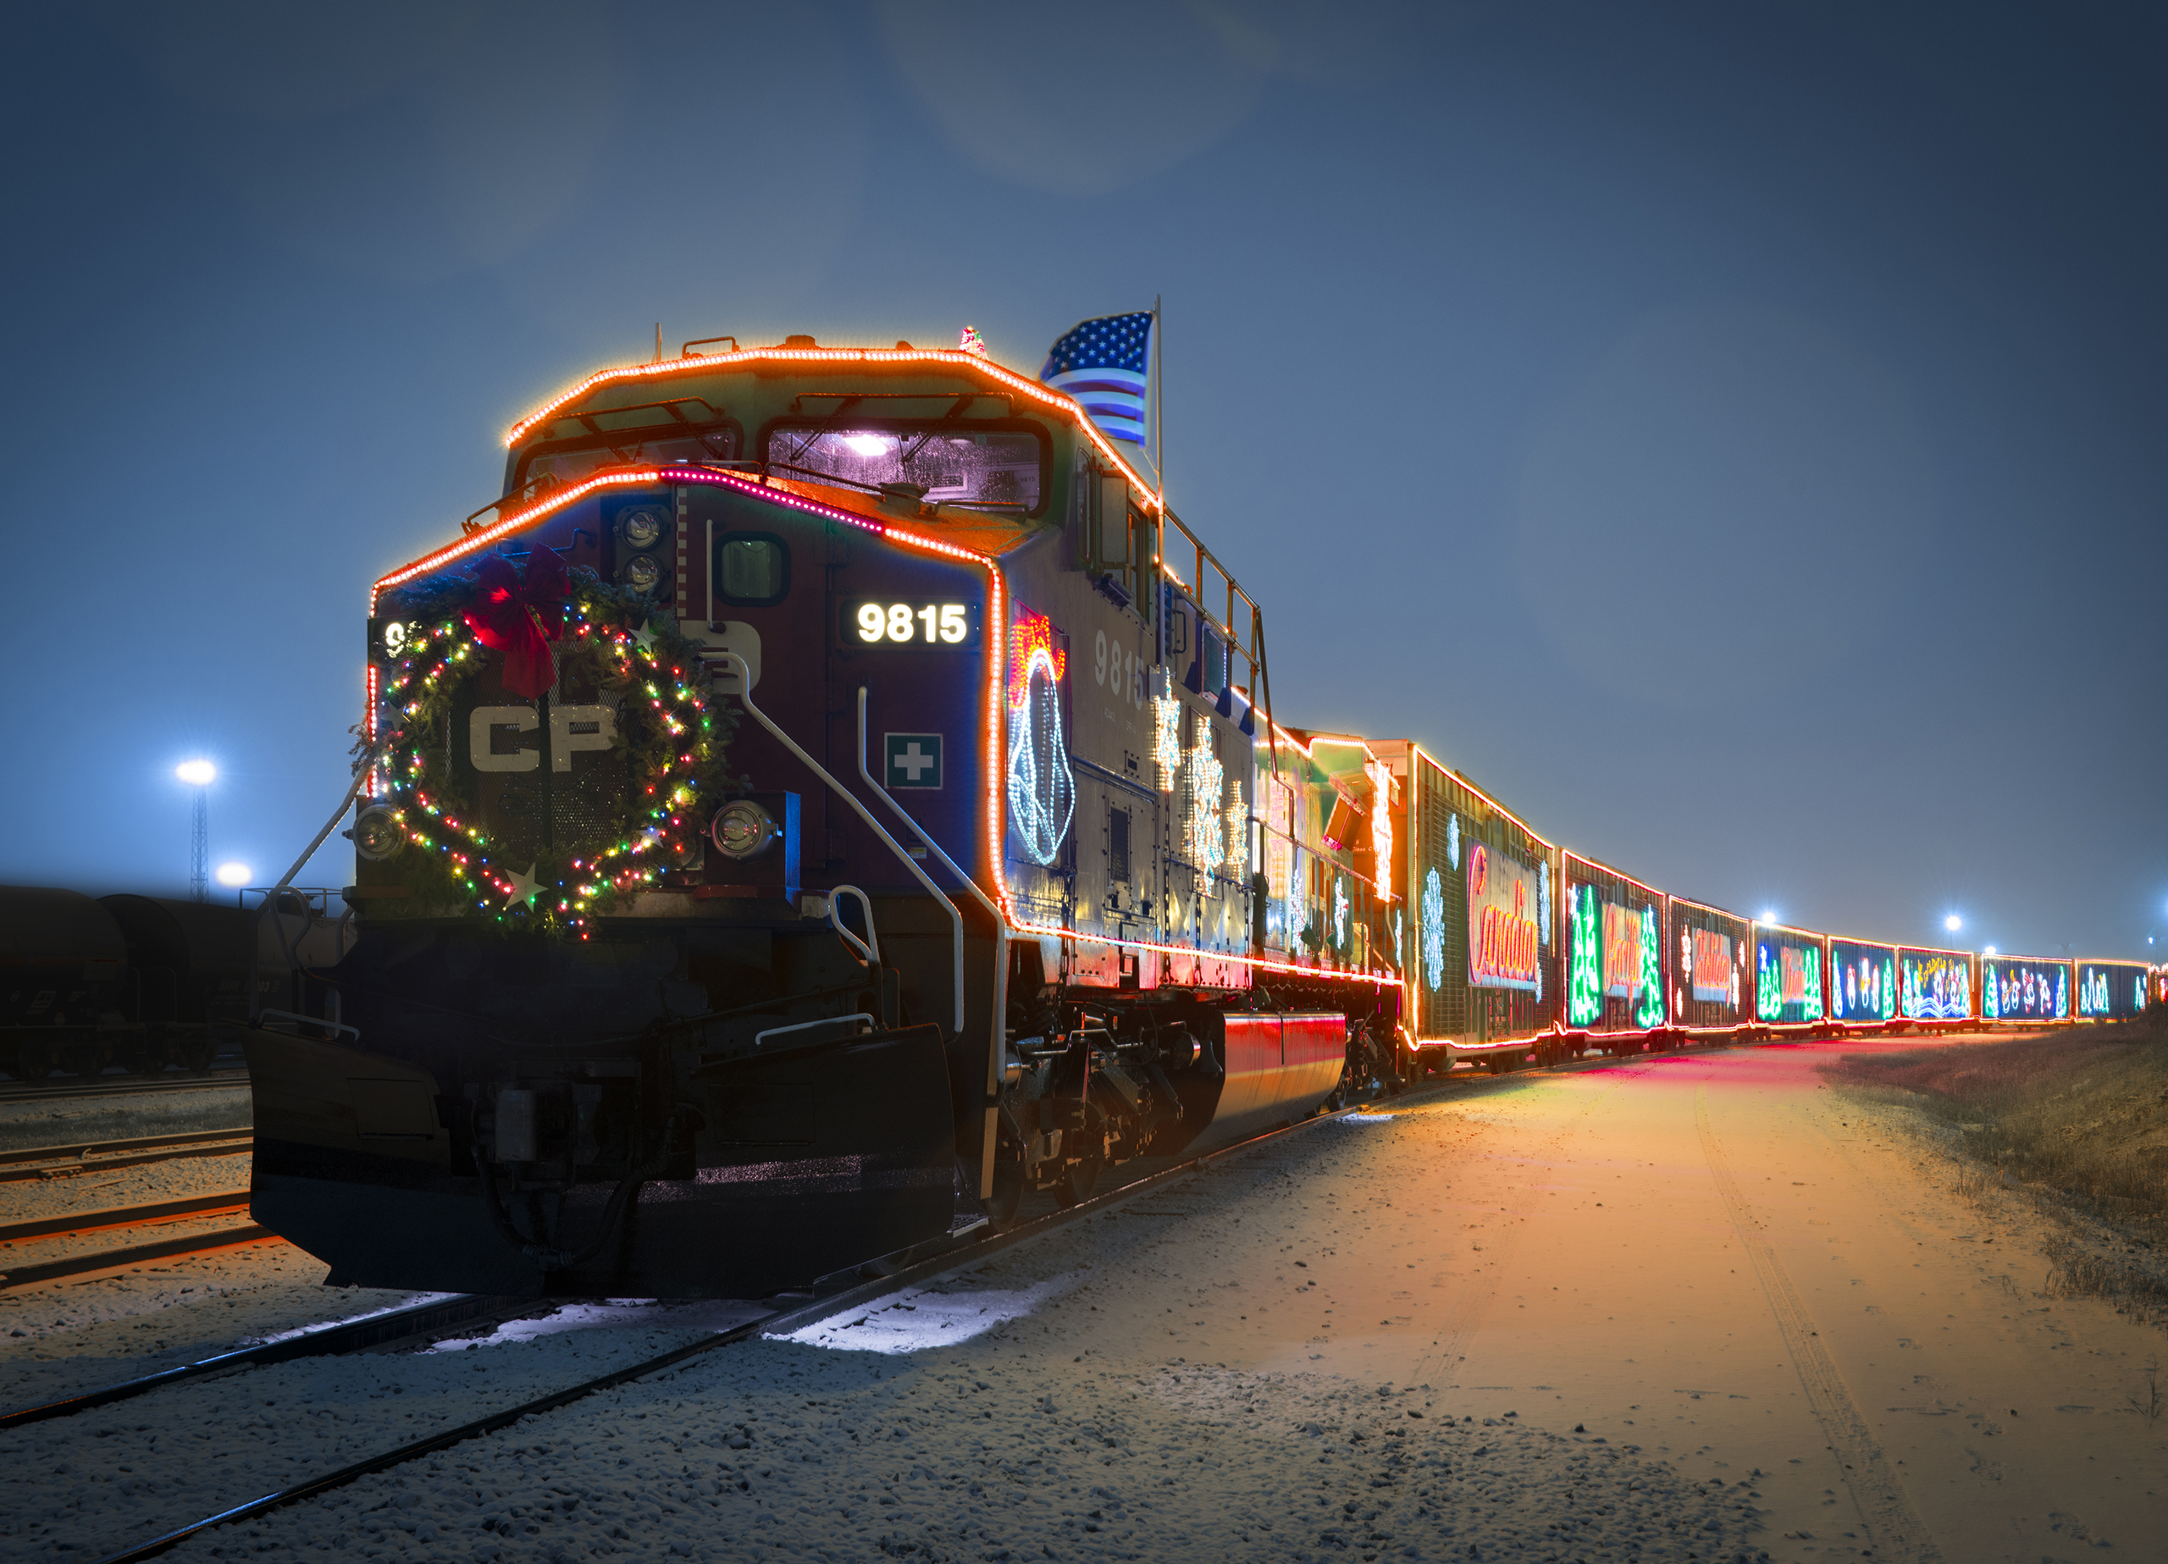
Nov. 30, 2019 8 p.m. – 1 a.m. Waterloo Depot
485 W Van Vleek Street, Waterloo IN 46793

Name of contact person__________________________ Business________________________________
Address: _____________________________________________________________________________
Contact phone number_______________________ Email Address_______________________________
SPONSORS: Sponsors are promoted in advance and at the event on banners and signage.
Sponsorship Levels (check one): ___ $250 – Logo & Name on all publicity
___$100 – Name/logo on event banner

VENDORS: We’ll provide a 10x10’ space under a large tent and marketing/promotions. You will not need a permit. Please bring your own tables, display equipment. Setup is after 1 p.m. in event tent or pavilion.

Booth spaces:
_____$20 Arts, Crafts and Food sales ______$10 Non-Profit Organization _____$5 electrical service fee

What type of products do you sell:_________________________________________________________

_____________________________________________________________________________________
Return this registration along with fees to:
Town Manager, Waterloo Main Street, P.O. Box 96 Waterloo, IN 46793

*date subject to change
Sponsored by Waterloo Main Street & Friends of the Depot.
Waterloo Main Street
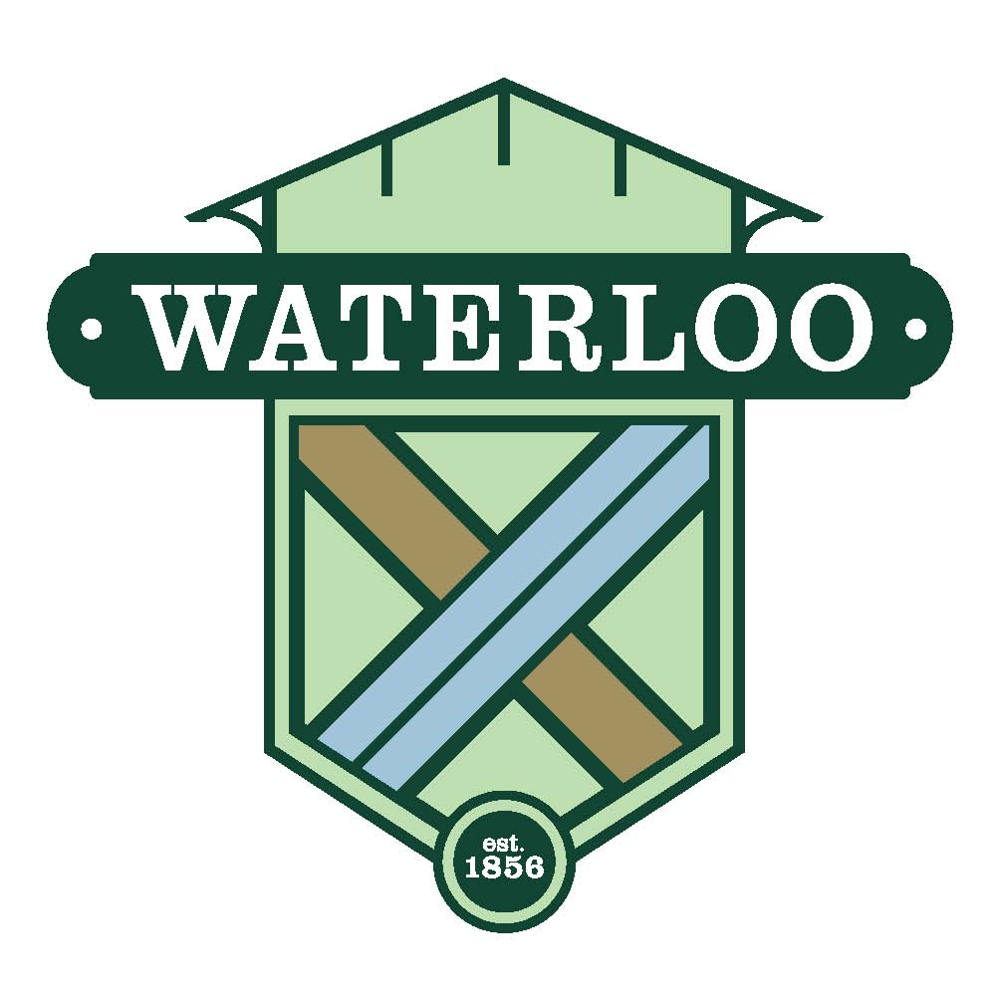
P.O. Box 96 280 S. Wayne Street
Waterloo, Indiana 46793
Tel: 260-837-7428 Fax: 260-837-3605
e-mail: townmanager@waterlooin.gov
Website: www.waterlooin.gov

August 7, 2019

The Town of Waterloo invites you to join us as a participant for our Holiday Train Block Party. This event will celebrate the 21st annual trip of the Canadian Pacific Holiday Train as it travels from Canada to Chicago covered in beautiful lights. We expect the train will pass through Waterloo on Saturday night, November 30, sometime after 11 p.m. Activities will begin at 8 p.m. and we’ll stay until the train goes by, usually its around midnight.

While we wait for the train, be part of the action with live entertainment, children's activities, food and beverage vendors, and an arts & craft marketplace while also collecting food pantry donations. As a sponsor or vendor, you're welcome to set up an information booth and promote your organization or products.

We realize this late time of day and November temperatures may dissuade artists and vendors but we’re going to do everything we can to make it fun. We’ll open the park pavilion and light the fireplace. We’ll provide large tents with heaters in the street by the depot. The train station will be open throughout the event.

Please support or participate in the Holiday Train Block Party. This kick-off to the holiday season is a great way to sell your products and/or show your support for Waterloo Main Street as a sponsor.

Please use the attached registration form to join us. Or contact me with any questions.

Sincerely,

Tena Woenker
Member
Waterloo Main Street

